**INDIVIDUAL EXERCISE**

You have been part of community of your school’s Computer Club. You have learned a lot about the new technologies in your developing applications for your school intranet. You as the leader of the community need to assign one big project on developing the **LIBRARY DATABASE SYSTEM** in your school. The system will using the intranet technology and involves the development of library system in your school.

1. Use the **Three-Sphere Model** of systems management to identify potential issues that could be that could be factors in deciding whether you should proceed with your idea to develop the library database system on your school. Include five questions for each sphere.

Three Sphere Model For **Library Database System**

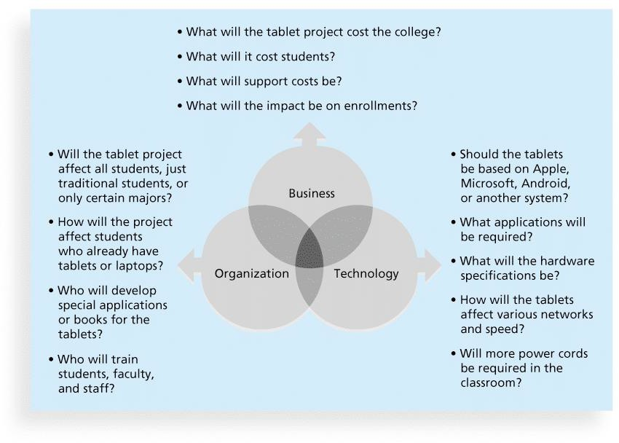

1. Write the Scope Management Plan
   1. **Project Title** : Southern University College Library Database System
   2. **Project Date** : 22/5/19 – 21/5/21
   3. **Project Manager** : Daniel Fok Choon Sing
   4. **Project Objective** : To make the Library System more easier to access
   5. **Project Scope** :

·An interface to view and edit the own profile.

·Provide method for adjusting account settings such as passwords.

·Mechanism to reset the password in case user forgets it.

·Providing interface to add or delete books to staffs.

·Facility to reserve books that are available.

* 1. **Role and Responsibility** :

|  |  |
| --- | --- |
| Programmer | Build up the Library System |
| Project Manager | Monitoring the project |
| System Analyst | Analysis the aim of System |
| Quality Assurance | Ensure the system work properly |

* 1. **Project Charter** : (Define 3 project charter)
     1. Project Charter Name: Describe the function of each project charter

·Login System

·Search Book System

·Penalty System

* + 1. Project Charter Date : Put the date Start and date Finish the project charter

·22/5/19 – 23/11/19

·24/11/19 – 25/5/20

·26/5/20 – 21/5/21

* + 1. Project Charter Scope: Write down five scopes for each project charter

-Admin and Student Login, User Database, Authentication, Friendly Use Login Page, High Secure

-

* 1. **Create the Work Breakdown Structure**
     1. Mind Map
     2. WBS in chart form
     3. List of WBS